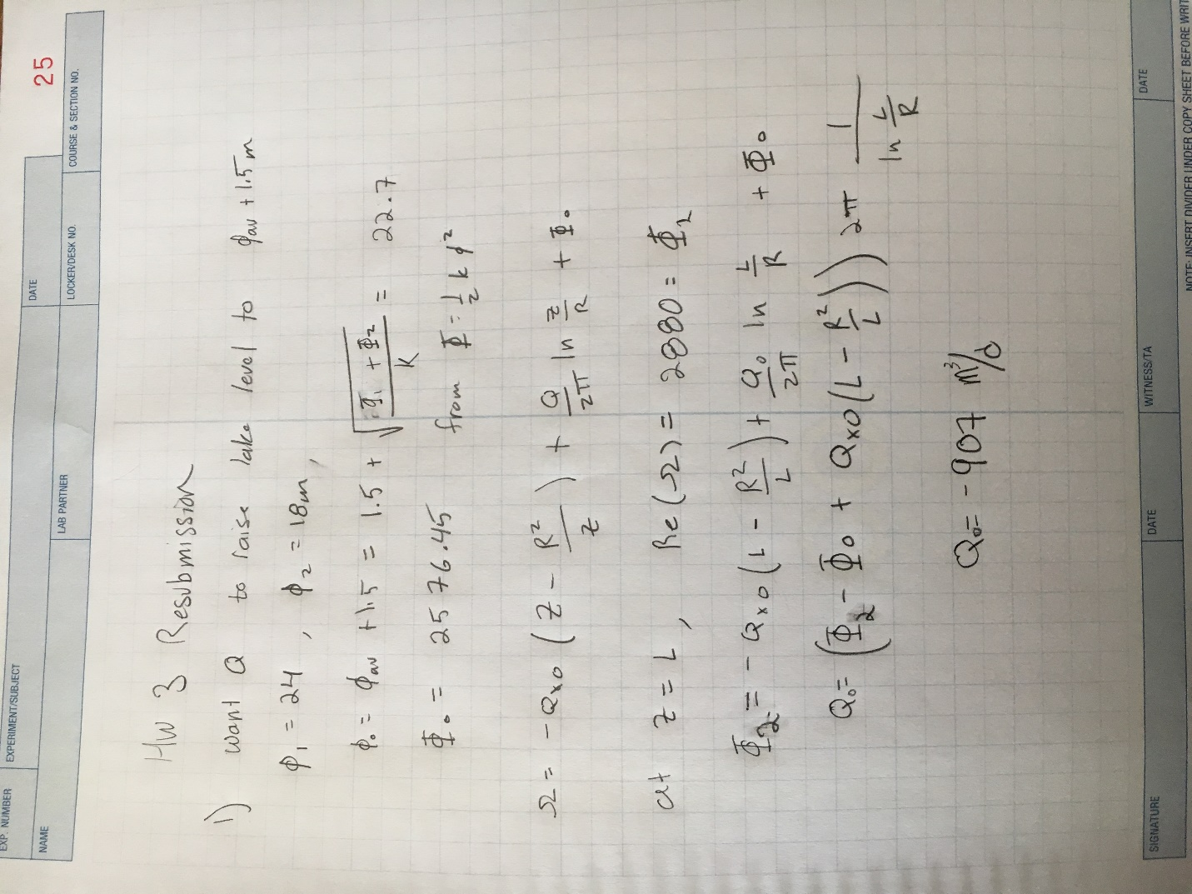

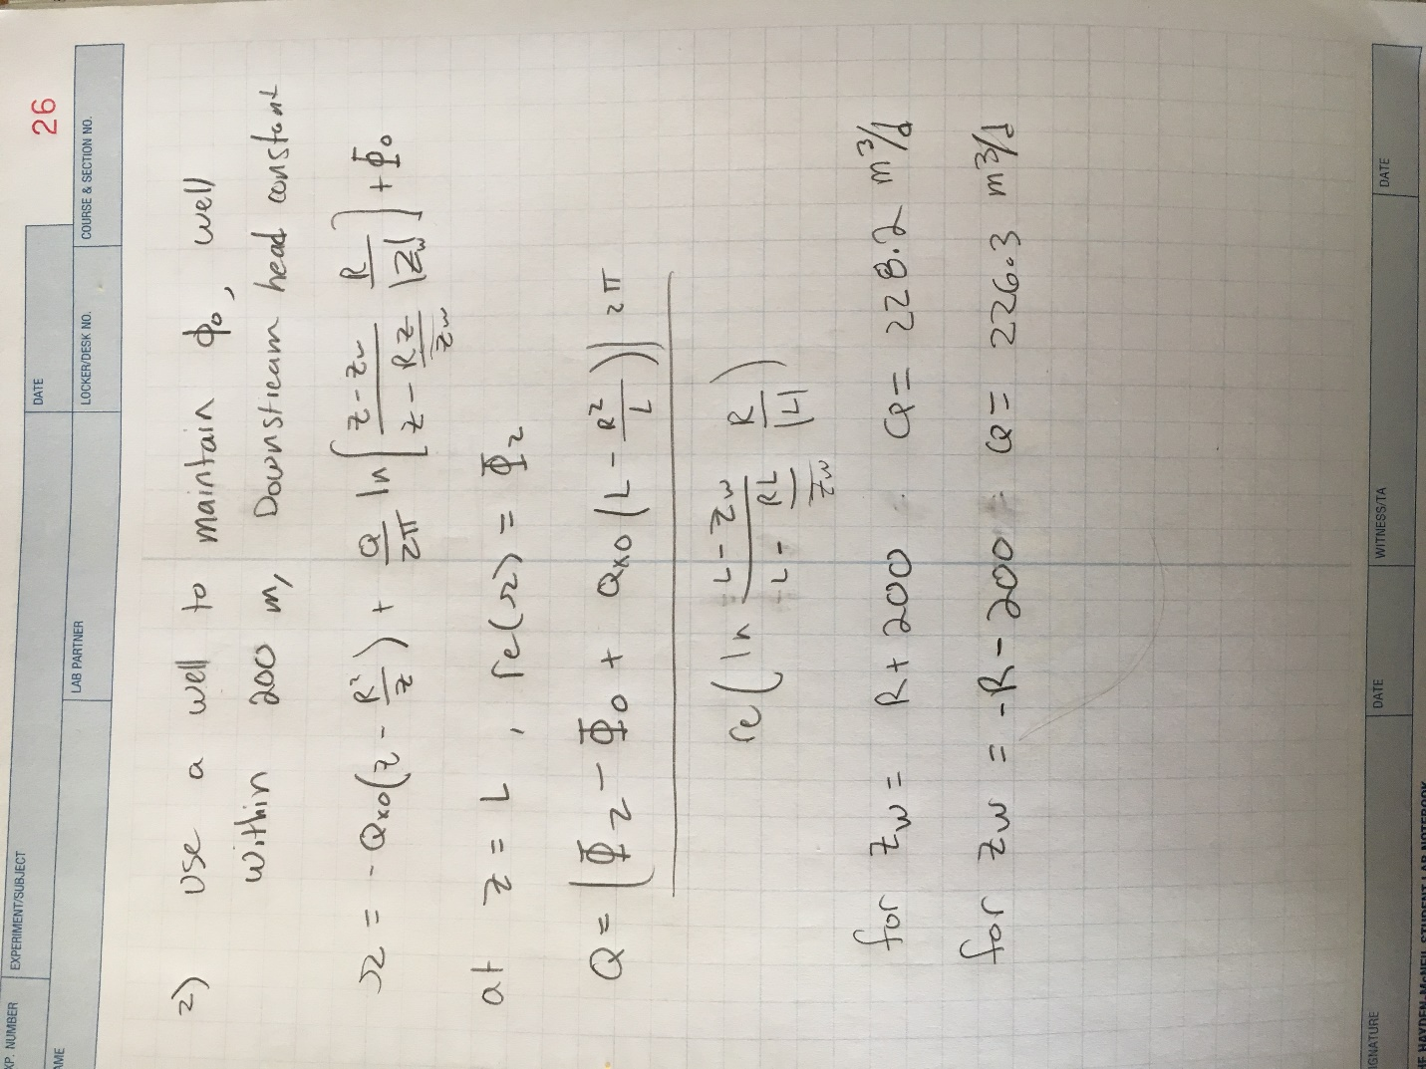

3) Less pumping is required when the well is located upgradient of the lake. More pumping is required when the well si downstream of the lake because the downstream well pulls more from the lake. The upstream well captures less water from the lake because the gradient from the well to the lake is less in the upstream case than the downstream case. The flownet for the upstream well placment resembles the flownet for the lake without the well more than the downstream well placment’s flownet.

4)

Lake above aquifer level:

Upstream well

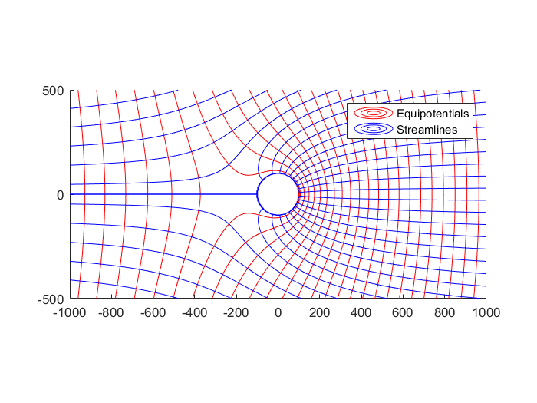

Upstream well:

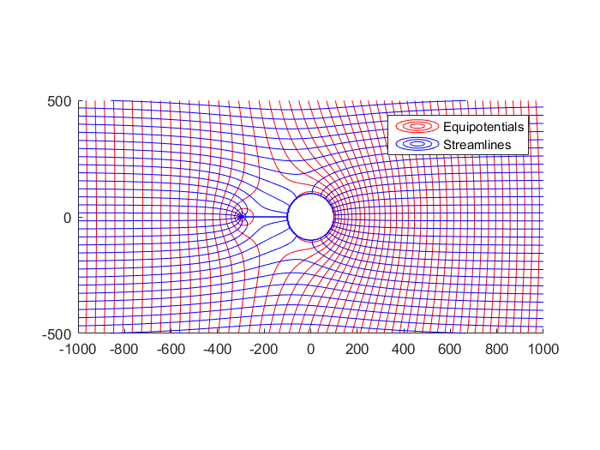

Downstream well:

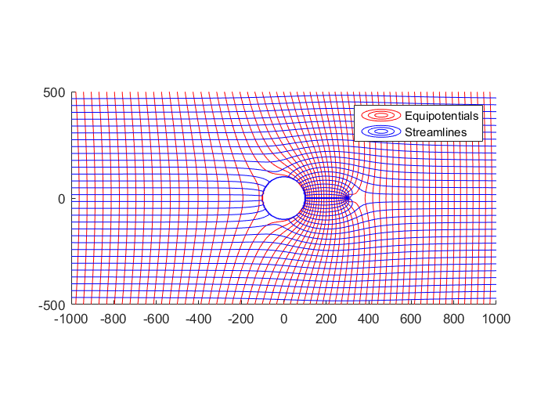

Code changes:

Runfile_1.m

Qx0 = 0.63;

Phi0= 2576.45;

rl= 100;

Phi1 = 2880

l = 1000

Phi2= 1620

Q= (Phi2 - Phi0 +Qx0*(l - rl*rl/l) )*2* pi/log(l/rl)

ContourMe_flow_net(-1000,1000,500,-500,500,500,@(z)omega_total1(z,Q,Qx0, Phi0, rl),30);

Runfile_2.m:

Qx0 = 0.63;

Phi0= 2576.45;

rl= 100;

Phi2 = 1620;

Phi1=2880;

l=1000;

zw =rl +200

Q=2*pi* (Phi2 - Phi0 + Qx0*(l+-rl*rl/l))/real(log((rl/(l*conj(l)))*(l-zw)/(l-rl*l/conj(zw))))

ContourMe_flow_net(-1000,1000,500,-500,500,500,@(z)omega_total2(z,zw,Q,Qx0, Phi0, rl),30);